Product Table
ProductID | Name | Price | Quantity
101 | Laptop | 45000 | 10
102 | Mobile | 25000 | 5

Supplier Table
SupplierID | Name | Contact | Email
1 | Lan | 734856643 | lan@gmail.com
2 | Bodo | 894214411 | bod@gmail.com

ProductSupplied Table
PO Number | ProductID | SupplierID | QuantitySupplied | Price
1 | 101 | 1 | 10 | 45000
2 | 102 | 2 | 5 | 25000

Bills Table
BillID | OrderID | BillDate | TotalAmount | PaymentMethod
201 | 5001 | 28/09/2024 | 45000 | Online
202 | 5002 | 30/09/2024 | 25000 | COD

Customer Table
CustomerID | Name | Email | Phone
201 | Johnny | joh@gmail.com | 8787470933
202 | Jaswant | jas@gmail.com | 8787470422

Order Table
OrderID | OrderDate | CustomerID | TotalAmount
5001 | 28/09/2024 | 201 | 45000
5002 | 29/09/2024 | 202 | 25000
OrderItem Table
OrderItemID | OrderID | ProductID | Quantity | ItemPrice
60001 | 5001 | 101 | 1 | 45000
60002 | 5002 | 102 | 1 | 25000

Relationships
- Supplier to ProductSupplied:
  - One-to-Many: A supplier can supply multiple records in the ProductSupplied table.
- Product to ProductSupplied:
  - One-to-Many: Each product can have multiple records in the ProductSupplied table (indicating supplies from different suppliers).
- Order to Customer:
  - Many-to-One: Each order is placed by one customer.
- Order to OrderItem:
  - One-to-Many: Each order can have multiple order items.
- Product to OrderItem:
  - One-to-Many: Each product can appear in multiple order items.
- Bill to Order:
  - One-to-One: Each bill corresponds to one order.

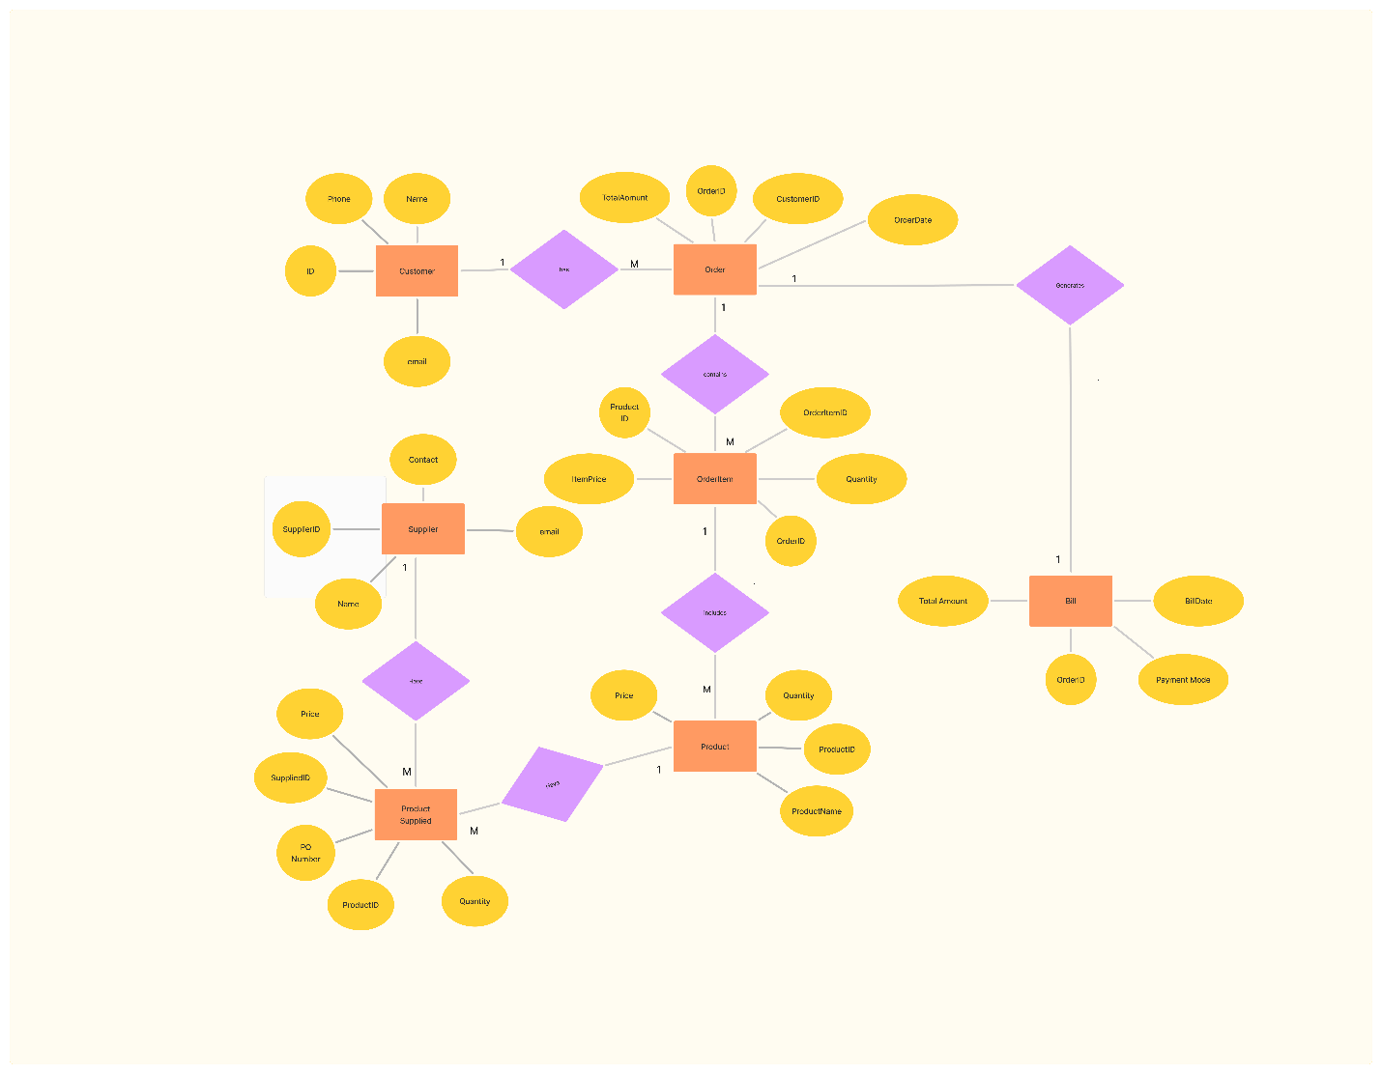

Stores Table
StoreID | StoreName | PhoneNumber | Address
1 | Video Haven | 111-222-3333 | 123 Main St, City A
2 | Movie World | 444-555-6666 | 456 Elm St, City B

Movies Table
MovieID | Title | Format | Category | StoreID
1 | Avengers: Endgame | DVD | Action | 1
2 | The Lion King | VHS | Adventure | 1
3 | Finding Nemo | DVD | Animation | 1
4 | The Hangover | VCD | Comedy | 2
5 | Jurassic Park | DVD | Sci-Fi | 2

Rentals Table
RentalID | MovieID | MemberID | DependentID | RentalDate | ReturnDate
1 | 1 | 1 | NULL | 2024-10-01 | 2024-10-08
2 | 4 | 2 | NULL | 2024-10-01 | 2024-10-08
3 | 3 | NULL | 1 | 2024-10-01 | 2024-10-08
4 | 2 | 3 | NULL | 2024-10-01 | 2024-10-08

Members Table
MemberID | Name | PhoneNumber | FavoriteCategory | MembershipType | StoreID
1 | Alice | 123-456-7890 | Action | Golden | 1
2 | Bob | 098-765-4321 | Comedy | Bronze | 1
3 | Charlie | 555-555-5555 | Sci-Fi | Golden | 2
Dependents Table
DependentID | Name | MemberID
1 | David | 1
2 | Eva | 1
3 | Frank | 2
4 | Grace | 3

Explanation of Relationships
- Stores to Movies:
  - Each store can have multiple movies (1).
  - StoreID in the Movies table serves as a foreign key linking each movie to its store.
- Movies to Rentals:
  - Each movie can be rented multiple times (1).
  - MovieID in the Rentals table serves as a foreign key linking rentals to specific movies.
- Rentals to Members and Dependents:
  - Each rental can be associated with either a member or a dependent.
  - MemberID and DependentID in the Rentals table are foreign keys linking to the respective tables. A rental can reference one member or one dependent but not both at the same time.
- Members to Dependents:
  - Each member can have multiple dependents (1).
  - MemberID in the Dependents table links dependents to their corresponding members.

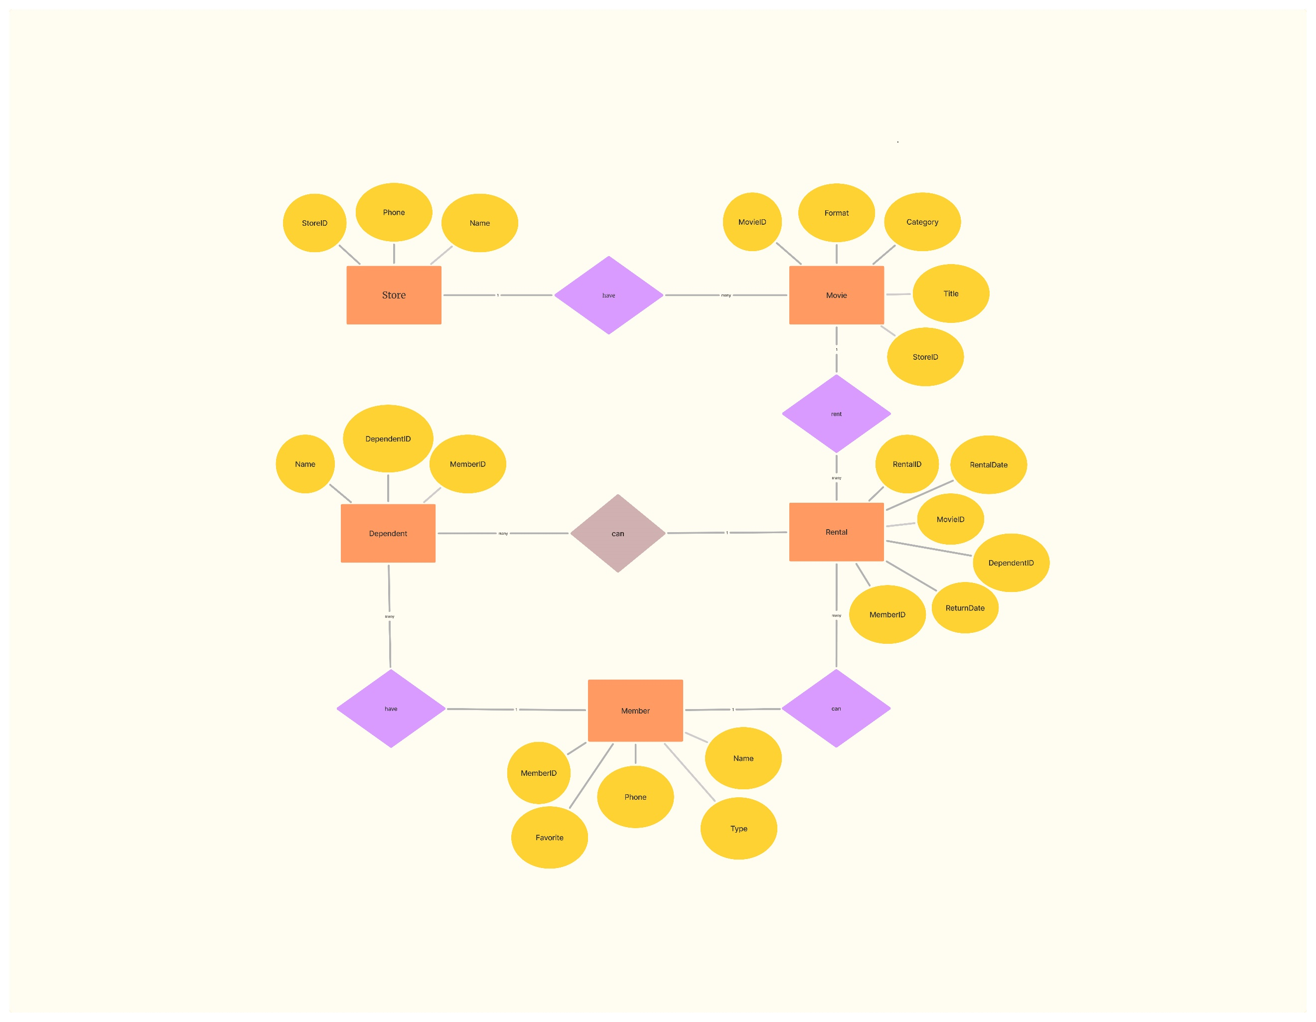

Student
StudentID | Name | Phone | Email | Address
1 | Alice | 8787470933 | alice@gmail.com | Noida sector 62
2 | Bob | 8787470933 | bob@gmail.com | Noida sector 63
3 | Charlie | 8787470933 | charlie@gmail.com | Noida sector 64

Instructor
InstructorID | InstructorName | Email
1 | Dr. Smith | smith@example.com
2 | Dr. Johnson | johnson@example.com
3 | Dr. Lee | lee@example.com

Course
CourseID | CourseName | InstructorID | ScheduleID
1 | Math | 1 | 1
2 | Science | 3 | 2

Schedules Table
ScheduleID | Day | TimeStart | TimeEnd | Room
1 | Mon | 10:00 | 11:00 | 101
2 | Tue | 11:00 | 12:00 | 102
3 | Wed | 9:00 | 10:00 | 103

Student_Instructor Table
StudentID | InstructorID
1 | 1
1 | 2
2 | 3
3 | 1
3 | 2

Relationships
- Student to Student_Instructor:
  - One-to-Many (One Student can have multiple entries in Student_Instructor)
- Instructor to Student_Instructor:
  - One-to-Many (One Instructor can have multiple students in Student_Instructor)
- Instructor to Course:
  - One-to-Many (One Instructor can teach multiple Courses)
- Course to Schedule:
  - One-to-One (One Course has one Schedule)
- Course to Student:
  - One-to-Many (One Course can have multiple Students)
- Schedule to Course:
  - One-to-Many (One Schedule can be linked to multiple Courses)

